Technical Story Card

Revision History
Version No. | Date | Prepared by / Modified by | Significant Changes

Glossary
Abbreviation | Description
BSC | Business Story Card
TSC | Technical Story Card

Table of Contents
1 Introduction 3
2 Scope of Change 3
3 List of impacted modules 3

3.1 Donator Module

3.2 Agent Module

3.3 Admin module

4 Design and Detailed technical updates 4
4.1 Process model 4
4.1.1 Use case Model 4
4.1.2 Sequence diagram 4
4.2 Proposed user Interface design 4
4.3 Database design changes 4
4.4 Refactoring related changes 4
4.5 Construction strategy and re-use 4
5 Details of Alternative Design Approach 4
6 Other Technical changes 5
6.1 Automation tasks / changes 5
6.2 CI / Build relates tasks / changes 5
6.3 Non-functional related changes 5
7 Additional details 5
7.1 Open Questions / clarifications / Assumptions 5
7.2 Additional notes to technical team 5
8 References 5

Introduction
This project is used to manage wastage foods in a useful way. Every day the people are wasting lots of foods. So we have to reduce that food wastage problem through online. This web application provides the interface between food donors and those who require the food. If anyone have extra food in their hotels or any function they can easily contact us though this web application. The donor can also create the account and whenever they are having wastage food. They can also login and give request to the admin for a donation. After the admin view the donator request and give the alert message to agent for collecting the food. After agent collect foods from donor then provide to nearest poor peoples.

Scope of Change
We can add more rural orphanages to the system so that many people can able to utilize the waste food.
We can also collect waste food not only from functions we can use more places where food is the main source of wastage.

List of impacted modules
    - Donator Module
    - Agent Module
    - Admin module

DATA FLOW DIAGRAM:

DFD LEVEL 0:

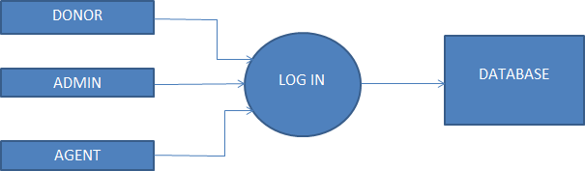

DFD LEVEL 1:

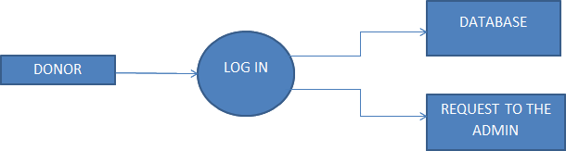
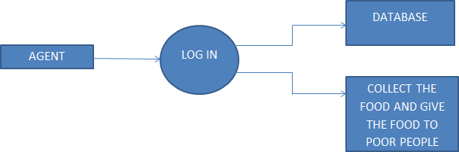

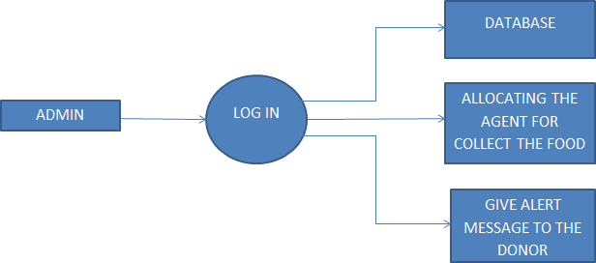

DFD LEVEL 2:
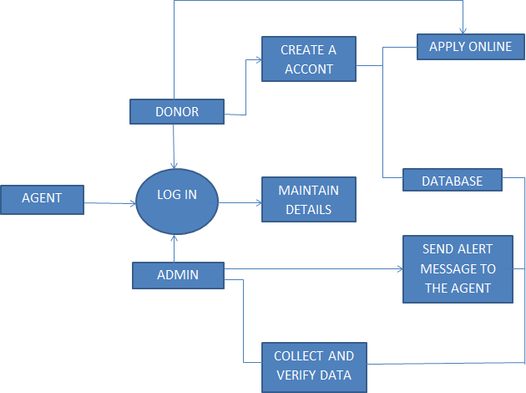

Design and Detailed technical updates

Process model
Process models are processes of the same nature that are classified together into a model. It track what actually happens during a process Take the point of view of an external observer who looks at the way a process has been performed and determines the improvements that must be made to make it perform more effectively or efficiently.

Use case Model


A use case diagram at its simplest is a representation of a user's interaction with the system that shows the relationship between the user and the different use cases in which the user is involved. In this context, a "system" is something being developed or operated, such as a web site. The "actors" are people or entities operating under defined roles within the system.
Login
Register
Donor
Register new childre
Admin
Check children details
view donor details

Sequence diagram

A use case diagram at its simplest is a representation of a user's interaction with the system that shows the relationship between the user and the different use cases in which the user is involved. In this context, a "system" is something being developed or operated, such as a web site. The "actors" are people or entities operating under defined roles within the system.

Register
Login
help children
view personal details
register new children login
view donor details
view children details
Donor
Admin
Database

Proposed user Interface design:

Registration Page:
Brief Description | Registration
Basic Flow | This use case describes how an Employee gets into User Profile page  - The client has to register himself into the system.  - The following information is required to Registration.  - First Name  - Last Name  - Phone No  - Password  - Confirm Password
Alternate Flow | - 1. The system will validate the credentials provided.
Validation | - Valid Username.  - Password is similar as Confirm Password
Pre-Conditions | User should have network access and Browser with latest updates.
Post-Conditions | Landing page has to be displayed.

Log In page:

Brief Description | Login
Basic Flow | This use case describes how an Employee gets into User Profile page  - The client has to register himself into the system.  - After the successful login, user will be taken to the appropriate landing page.  - The following information is required to login.  - Phone Number  - Password
Alternate Flow | - The system will validate the credentials provided. If credentials are invalid, login form will be redirected again with error message.
Validation | - Valid Username
Pre-Conditions | User should have network access and Browser with latest updates.
Post-Conditions | Landing page has to be displayed.

Add New Agent:
Brief Description | Add Agent
Basic Flow | This use case describes how a Agent profile in to the system  1. The following information is required during Add an Agent..  - Agent Name  - Agent Place  - Agent Phone Number
Alternate Flow | The system will validate the credentials provided
Validation | 1. Name is required and minimum 3 characters and max 30 characters.  2. Place should be valid.  3. Valid 10 digit phone number.
Pre-Conditions | User should have network access and Browser with latest updates.
Post-Conditions | Success message should be shown “Agent added Successfully”.

Add Hotel Details, Orphanages Details:
Brief Description | Add Hotel details, Orphanages details
Basic Flow | This use case describes how a Hotel details, Orphanages details in to the system  1. The following information is required during Add an Details..  - Name  - Place  - Phone Number
Alternate Flow | The system will validate the credentials provided
Validation | 1. Name is required and minimum 3 characters and max 30 characters.  2. Place should be valid.  3. Valid 10 digit phone number.
Pre-Conditions | User should have network access and Browser with latest updates.
Post-Conditions | Success message should be shown “Details added Successfully”.

Database design changes:
ER-DIAGRAM:

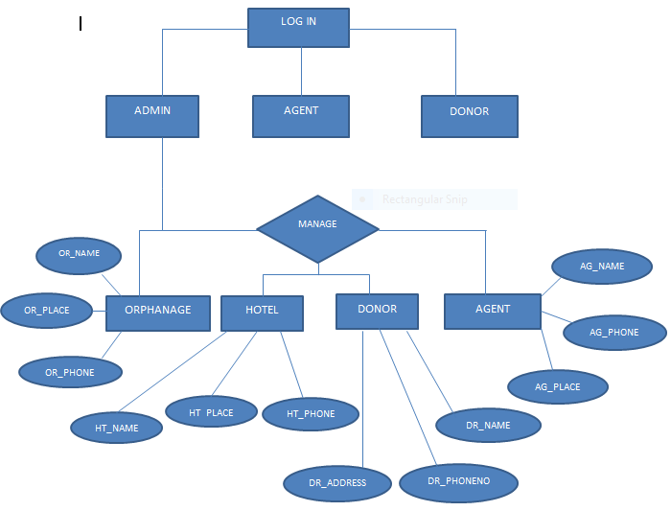

Table structure for table admin:

Field | Type | Null | Default
username | varchar(30) | NO | NOT NULL
password | varchar(30) | NO | NOT NULL

Table structure for table donate:

Field | Type | Null | Default
Id | int(11) | NO | NOT NULL
Uname | varchar(20) | NO | NOT NULL
donate_for | varchar(30) | NO | NOT NULL
Amount | int(11) | NO | NOT NULL
given_to | varchar(50) | NO | NOT NULL
Details | varchar(100) | NO | NOT NULL
Rdate | varchar(15) | NO | NOT NULL

Table structure for table reg_people:
Field | Type | Null | Default
Id | int(11) | NO | NOT NULL
Ptype | varchar(20) | NO | NOT NULL
Name | varchar(20) | NO | NOT NULL
Gender | varchar(10) | NO | NOT NULL
Dob | varchar(15) | NO | NOT NULL
Age | int(11) | NO | NOT NULL
Address | varchar(50) | NO | NOT NULL
District | varchar(30) | NO | NOT NULL
date | varchar(15) | NO | NOT NULL

Table structure for table reg_user:

Field | Type | Null | Default
Id | int(11) | NO | NOT NULL
Name | varchar(30) | NO | NOT NULL
Address | varchar(50) | NO | NOT NULL
Contact | varchar(20) | NO | NOT NULL
Email | varchar(50) | NO | NOT NULL
Uname | varchar(30) | NO | NOT NULL
Pass | varchar(30) | NO | NOT NULL
Regdate | varchar(15) | NO | NOT NULL

Table structure for table request:

Field | Type | Null | Default
Id | int(11) | NO | NOT NULL
Name | varchar(20) | NO | NOT NULL
Address | varchar(50) | NO | NOT NULL
District | varchar(20) | NO | NOT NULL
Contact | varchar(30) | NO | NOT NULL
Trust | varchar(30) | NO | NOT NULL
Details | text | NO | NOT NULL
Rdate | varchar(15) | NO | NOT NULL

Refactoring related changes
<Mention details of code re-factoring requirements; objective and scope of re-factoring and Changes to be done >

Construction strategy and re-use
< Mention about automated code development (using code-generator) or manual coding. Also identify make/buy/reuse components involved, if any >

Details of Alternative Design Approach
<Details of the alternative approach to resolve the maintenance request>

Other Technical changes

Automation tasks
<if the story is about automation (of test cases or some POC etc.), mention the details here>

CI / Build relates tasks
<If the story requirements are about implementation of continuous integration or build, update the details to be done here>

Non-functional related changes
<Non-functional requirements related to response time, System load or Network load>

Additional details

Open Questions / clarifications / Assumptions
<Mention the details of any open technical questions/clarifications or assumptions made, pertaining to story >

Additional notes to technical team
<provide details if any>

References
< Provide reference details if any >

